Macrosystems EDDIE: Macro-Scale Feedbacks

**Student Handout**

# Learning Objectives:

By the end of this module, you will be able to:

* Understand concepts in macrosystems ecology and macro-scale feedbacks, and how different ecological processes can interact at local, regional, and continental scales.
* Simulate greenhouse gas fluxes in multiple lakes using ecosystem models set up with publicly-available high-frequency sensor datasets (Activity A).
* Test the effects of a climate scenario on the different lake models and examine how the timing and magnitude of greenhouse gas fluxes change with climate warming (Activity B).
* Examine how local conditions may alter the timing and magnitude of greenhouse gas fluxes from lakes to affect global climate change (Activity C).
* Predict how lake greenhouse gas fluxes may both respond to and amplify a changing climate.

# Why macrosystems ecology?

***Macrosystems ecology*** is the study of ecological dynamics at multiple interacting spatial and temporal scales (e.g., Heffernan et al. 2014). Macrosystems ecology recently emerged as a new sub-discipline of ecology to study ecosystems and ecological communities around the globe that are changing at an unprecedented rate because of human activities (IPCC 2013). The responses of ecosystems and communities are complex, non-linear, and driven by feedbacks across local, regional, and global scales (Heffernan et al. 2014). These characteristics necessitate novel approaches for making predictions about how systems may change across time and space. Consequently, macrosystems ecologists are increasingly combining large datasets of sensor observations with simulation models of ecological phenomena to predict how changes in climate, land use, and other factors may affect the structure and function of communities and ecosystems (Weathers et al. 2016).

## A macrosystems approach to lake ecology

Using a macrosystems approach is necessary for studying environmental challenges that are driven by multiple factors across space and over time. In freshwater lakes and reservoirs worldwide, carbon cycling and subsequent carbon dioxide (CO2) and methane (CH4) fluxes are changing due to local, regional, and continental drivers (Butman et al. 2018). These fluxes can be either positive (i.e., the lake emits CO2 and CH4 into the atmosphere) or negative (i.e., CO2 and CH4 are taken up by the lake and removed from the atmosphere). As lakes warm due to climate change, they may exhibit more negative CO2 fluxes as warmer water temperatures stimulate phytoplankton growth, resulting in higher rates of photosynthesis and greater CO2 uptake. Conversely, warming lakes may exhibit greater positive CH4 fluxes because warming can decrease oxygen concentrations in lake bottom waters, increasing CH4 production at the lake sediments and subsequent release into the atmosphere.

We quantify the net effect of lake CO2 and CH4 fluxes on atmospheric warming using Global Warming Potentials (GWPs), a metric of how much energy greenhouse gases absorb in CO2 mass units (Myhre et al. 2013). Because one gram of CH4 absorbs 86 times as much energy as one gram of CO2, CH4 is assigned a GWP of 86 over a 20-year time horizon (CO2 is assigned a GWP of 1). We sum all of the CO2 and CH4 fluxes from a lake over a year to calculate its GWP and compare it with other lakes.

In many lakes, warming due to climate change could create a ***macro-scale feedback***, in which processes occurring on different scales interact to amplify (positive feedback) or diminish (negative feedback) each other (following Heffernan et al. 2014). For example, a positive macro-scale feedback could occur when local air temperatures warm, amplifying lake CH4 fluxes to the atmosphere, which in turn amplifies global climate change and further increases air temperatures. Both local and global drivers interact to change carbon cycling and CO2 and CH4 fluxes in lakes, though the direction and magnitude of fluxes vary substantially among lakes due to differences in their baseline phytoplankton levels, oxygen concentrations, and other factors.

In this module, you will work with a partner to study how carbon cycling in lakes will respond to warming due to climate change using an ecosystem simulation model, with the goal of predicting how local and global drivers will interact to amplify or diminish greenhouse gas fluxes in different lakes. We will examine how local and global processes interact to create macro-scale feedbacks that produce macrosystem-level phenomena (here, focusing on greenhouse gas fluxes in lakes across the U.S.).

# Module overview:

1. Introduction to Macrosystems Ecology: pre-readings and PowerPoint in class
2. Download and set up R software and module files on your computer
3. Activity A: Explore and run a lake ecosystem model in R that simulates carbon cycling
4. Activity B: Generate hypotheses about how lake CO2 and CH4 fluxes will respond to climate warming, and model how different lakes respond
5. Activity C: Calculate global warming potentials for your lake for baseline and climate scenarios, compare your lake’s greenhouse gas fluxes with other lakes, and make predictions about macro-scale feedbacks operating on lake greenhouse gas emissions at the local, regional, and global scales.

# Optional pre-class readings:

* Heffernan, J.B., et al. 2014. Macrosystems ecology: understanding ecological patterns and processes at continental scales. Frontiers in Ecology and the Environment 12: 5-14.
* EPA 2019. Understanding global warming potentials. https://www.epa.gov/ghgemissions/understanding-global-warming-potentials
* Tranvik, L.J., et al. 2009. Lakes and reservoirs as regulators of carbon cycling and climate. Limnology and Oceanography. 54: 2298-2314. (Especially focus on pages 2298-2302)

# Today’s focal question:

## *How will warming temperatures and local lake characteristics interact to create* ***macro-scale feedbacks*** *by altering lake greenhouse gas fluxes?*

To address this question, we will use an open-source model called GLM-AED (General Lake Model-Aquatic EcoDynamics; Hipsey et al. 2019). The GLM-AED model requires two input files: a meteorological driver file that contains multiple weather variables (including air temperature, solar radiation, wind, and precipitation) and an inflow driver file that contains variables for the streams entering the lake. GLM-AED also has four configuration or 'master script' files called nml files (named glm2.nml, aed2.nml, aed2_phytos_pars.nml, and aed2_zoops_pars.nml) that give basic information about the lake (e.g., maximum depth, latitude, lake name, etc.) and instructions for how the model will run. These instructions include the simulation start and end dates, the time step of the model, and the names of the meteorological and inflow data files. From both the input and configuration files, the model will simulate a range of variables, including CO2 and CH4 fluxes at the lake air-water interface. For more information about GLM, see: <http://aed.see.uwa.edu.au/research/models/GLM>.

We will be running GLM-AED models configured for different lakes to compare how lakes with different baseline conditions respond to warming air temperatures. Our module includes lakes that are part of GLEON, the Global Lake Ecological Observatory Network ([gleon.org](http://www.gleon.org)), an organization of scientists who collect and share high-resolution sensor data to study how lakes are changing in response to human activities. Some of our lakes are also part of NEON, the National Ecological Observatory Network ([neonscience.org](http://www.neonscience.org)), which is a continental-scale network collecting high-frequency data at sites across the United States to understand how ecosystems are changing.

These models were set up using high-frequency datasets from GLEON, NEON, and NOAA (U.S. National Oceanic and Atmospheric Administration). We made some changes to the lake models to simplify the surface water hydrology for this module.

# Setting up R software and files:

If you have not already downloaded R and RStudio, you will need to complete that step first. You can use the file 'R You Ready for EDDIE' for help. Once you have R and RStudio installed, all the information you need for the modeling activities is embedded into the R scripts within the zipped module project folders for RStudio. First, download the zipped folder, then unzip the folder and open the R script (MSF_R_Script.R). During class, read through the annotation for each step so that you understand what is happening in each of the lines of code that you are running.

# References:

Butman, D., et al., 2018: Chapter 14: Inland waters. In Second State of the Carbon Cycle Report (SOCCR2): A Sustained Assessment Report [Cavallaro, N., et al. (eds.)]. U.S. Global Change Research Program, Washington, DC, USA, pp. 568-595, https://doi.org/10.7930/SOCCR2.2018.Ch14.

Heffernan, J. B., et al. 2014. Macrosystems ecology: Understanding ecological patterns and processes at continental scales. Frontiers in Ecology and the Environment 12:5–14.

Hipsey, M. R., et al. 2019. A General Lake Model (GLM 3.0) for linking with high-frequency sensor data from the Global Lake Ecological Observatory Network (GLEON). Geoscientific Model Development 12:473–523.

IPCC. 2013. Climate Change 2013: The Physical Science Basis. Contribution of Working Group I to the Fifth Assessment Report of the Intergovernmental Panel on Climate Change. (T. F. Stocker, et al., eds.). Cambridge Univ. Press, NY.

Myhre, G., et al. 2013. "Anthropogenic and Natural Radiative Forcing". In: Climate Change 2013: The Physical Science Basis. Contribution of Working Group I to the Fifth Assessment Report of the Intergovernmental Panel on Climate Change. Stocker, T.F., et al. (eds.). Cambridge University Press, New York.

Weathers, K. C., et al. 2016. Frontiers in Ecosystem Ecology from a Community Perspective: The Future is Boundless and Bright. Ecosystems 19:753–770.

**As you go through the module, you’ll answer the questions below and turn in your answers at the end of the activity for credit.**

# Name:

# Pre-Module Activity:

1. 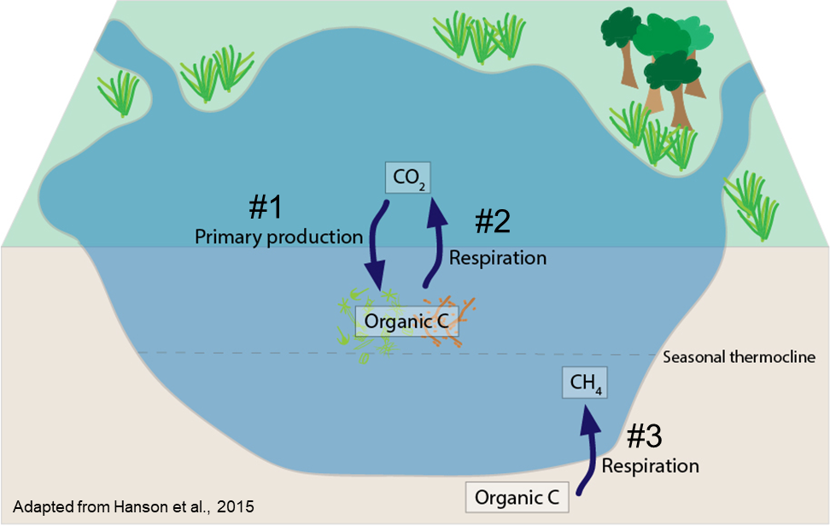Work with your partner and use the following diagrams to think about how CO2 and CH4 *concentrations* (denoted by the [ ]) in lakes may change under a warmer climate. Think about how each process will change ***individually***(we don’t really know how things will change when they interact!)*.* **Circle ‘Increase’, ‘Decrease’, or ‘No Change’ within each box to indicate how you predict CO2 and CH4 concentrations in the lake will respond to each scenario.** The conceptual figure will help guide your hypotheses in Activity A. We will then discuss answers as a class.

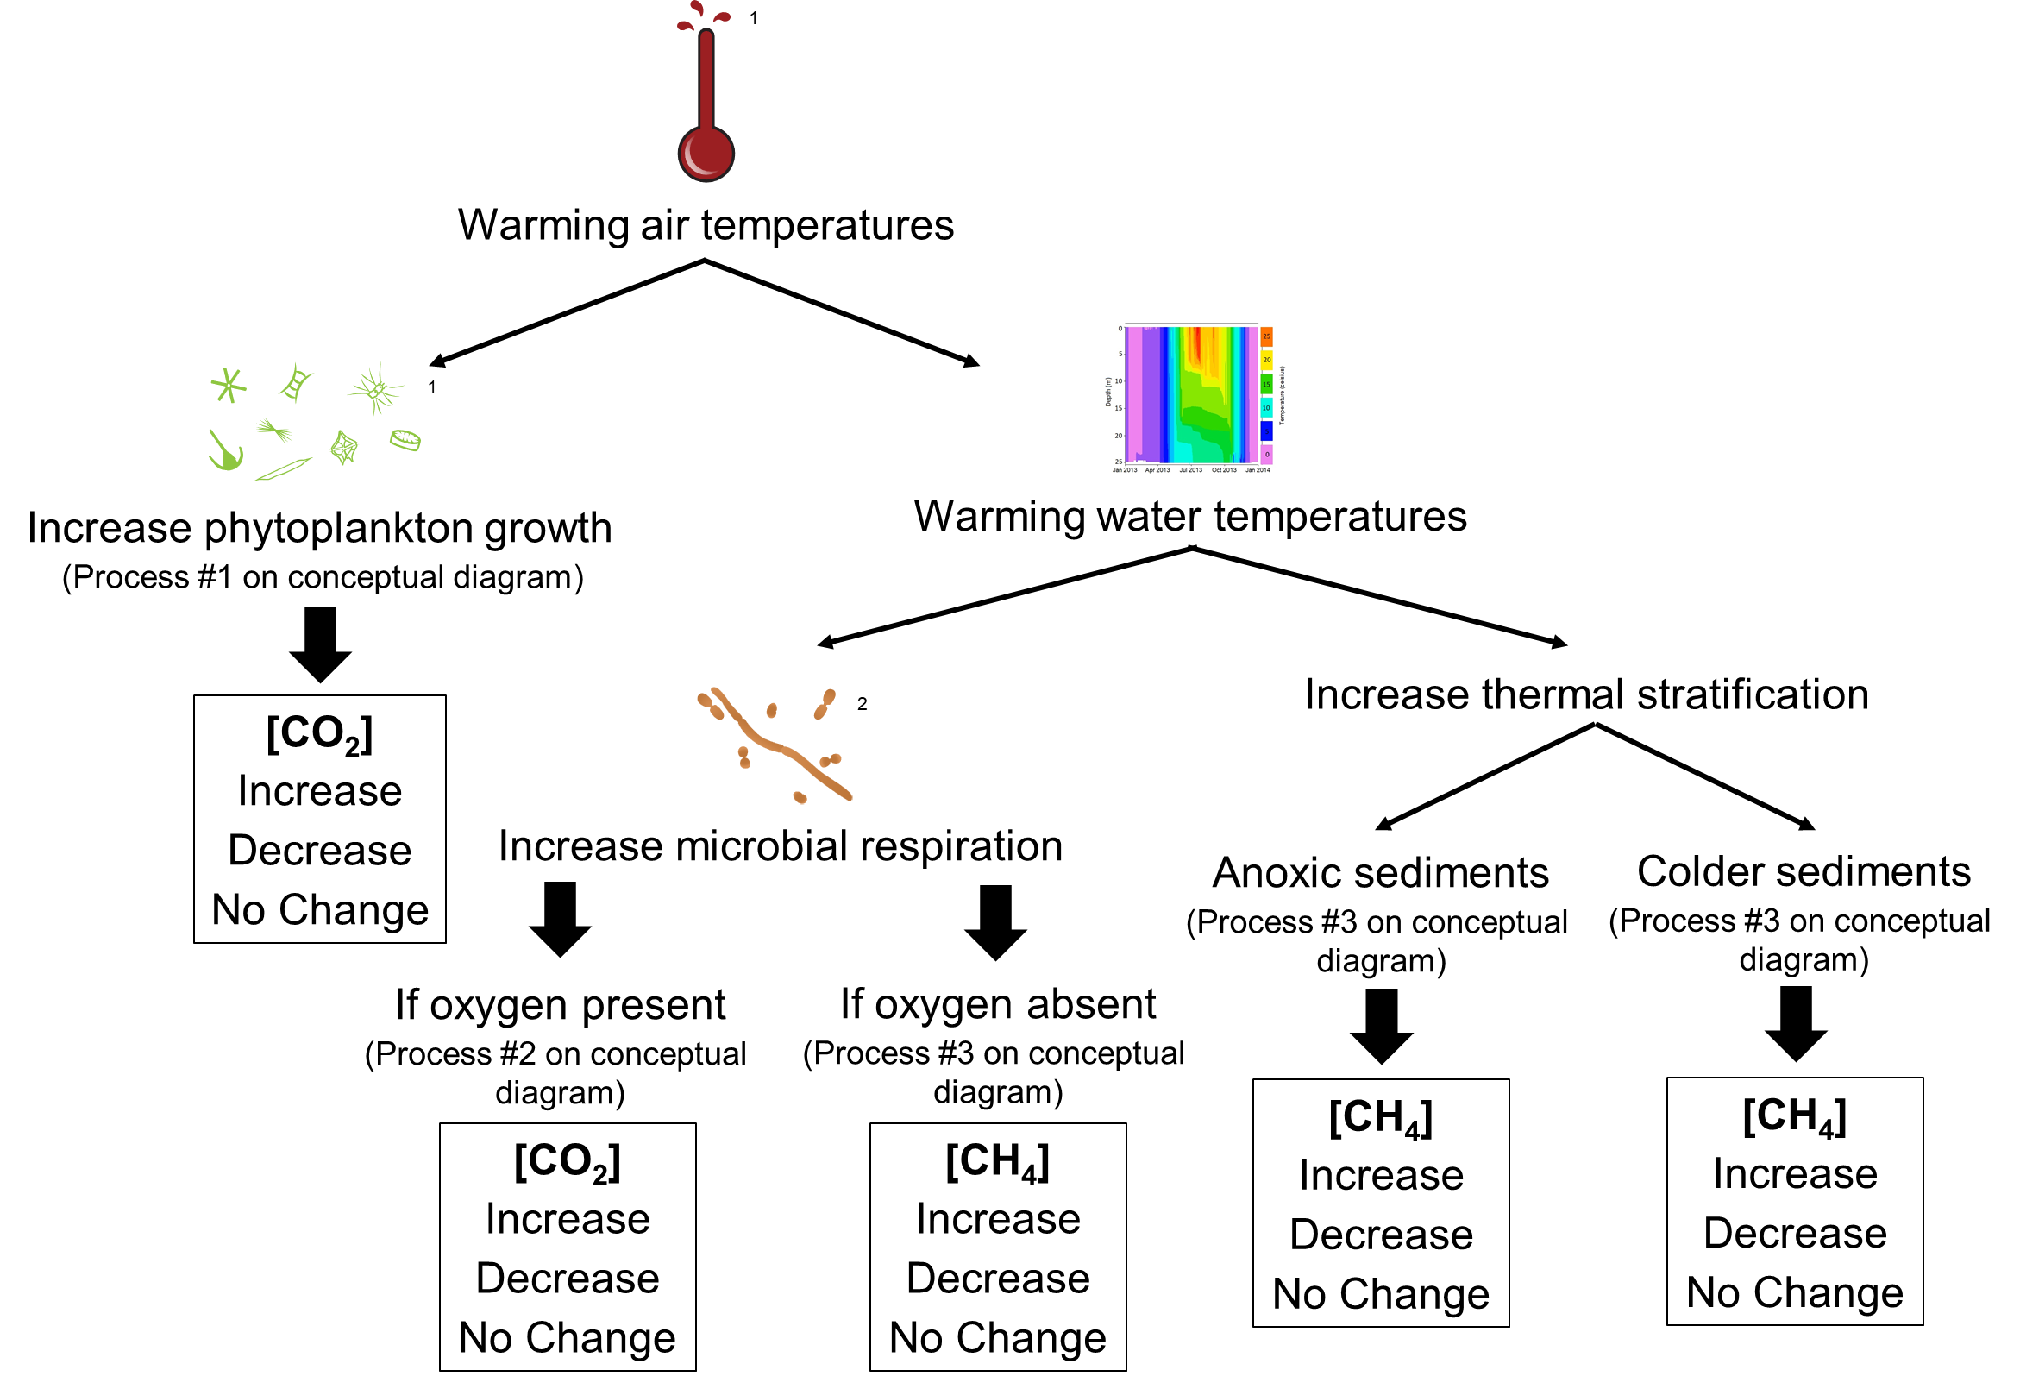1 T. Saxby, Integration and Application Network, University of Maryland Center of Environmental Science (ian.umces.edu/imagelibrary/).

2 K. Kraeer and L. Van Essen-Fishman, Integration and Application Network, University of Maryland Center of Environmental Science (ian.umces.edu/imagelibrary/).

Now that you’ve thought about how [CO2] and [CH4­] *concentrations* will change in the lake, questions 2-4 will explore how CO2 and CH4 *fluxes* may change under increased warming. This can be a positive flux, in which there is release of CO2 or CH4 to the atmosphere from processes in the lake or a negative flux, in which CO2 and CH4 are being taken up by processes in the lake.

1. Increased warming may stimulate phytoplankton growth – how might this affect CO2 and CH4 fluxes in lakes? Explain your reasoning.
2. Increased warming may decrease oxygen concentrations in lakes – how might this affect CO2 and CH­4 fluxes in lakes? Explain your reasoning.
3. Increased warming may increase microbial respiration – how might this affect CO2 and CH4 fluxes in lakes? Explain your reasoning.

# Think about it!

With a partner, look at the map and table below, and answer the following questions. **It is important to note that there are no 'correct' answers for this worksheet!** We do not know exactly how things will change in the future (and is why we use models to try to predict the future). The important part is to think through each question and provide plenty of (logical!) reasoning for your answer.

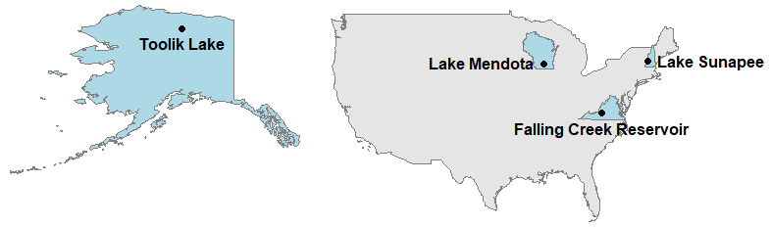

|  |  |  |  |  |
| --- | --- | --- | --- | --- |
| **Lake Name** | **Falling Creeka** | **Mendotab** | **Sunapeec** | **Toolikd** |
| **City, State (USA)** | Blue Ridge, Virginia | Madison, Wisconsin | Sunapee, New Hampshire | Alaska |
| **Latitude & Longitude** | 37.30, -79.84 | 43.11, -89.42 | 43.38, -72.05 | 68.63, -149.61 |
| **Mean annual air temperature (°C)** | +13.9 | +7.9 | +7.5 | -8.0 |
| **Surface area (km2)** | 0.12 | 39.39 | 16.74 | 1.46 |
| **Water quality** | Eutrophic (high nitrogen & phosphorus) | Eutrophic (high nitrogen & phosphorus) | Oligotrophic (low nitrogen & phosphorus) | Oligotrophic (low nitrogen & phosphorus) |

Data providers: a C. Carey & GLEON; b P. Hanson, North Temperate Lakes Long-Term Ecological Research, & GLEON, c K. Weathers, Lake Sunapee Protective Association, & GLEON, d G. Kling, Toolik Long-Term Ecological Research, & NEON

1. Under baseline conditions, do you expect your lake to be a CO2 source (positive flux) or a CO2 sink (negative flux) to the atmosphere? Why?
2. Under baseline conditions, do you expect your lake to be a CH4 source (positive flux) or a CH4 sink (negative flux) to the atmosphere? Why?

# Activity A: Plot water temperature and greenhouse gas fluxes in your model lake

Before getting started, make sure you have **unzipped** the ‘macroscale_feedbacks’ folder to your **Desktop**.

1. Objective 1: With a partner, look up the location of your focal model lake using a web mapping tool (e.g., Google Maps in “Satellite” mode). Where is your lake located? When looking at the satellite version of the map, what do you notice about the lake's watershed?
2. With your partner, work through Objective 1 in the R script to set up the GLM files and R packages on your computer for your model lake. **Make sure you read each line of code that starts with #. These comments will explain what the code is doing.** To run your model, you first have to identify your 'sim_folder' to set your working directory - read through the R script notes to find out how. Once you have determined your sim_folder location, write it here (and don’t forget to also change it in the R script!):

sim_folder <- '/Users/_________________/Desktop/macroscale_feedbacks/____________'

1. Run the GLM model and explore the output for temperature, dissolved oxygen, and CO2 and CH4 fluxes (Objective 2).
   1. Look at the greenhouse gas flux plots: when is there the largest flux of CO2 during the year? CH4? Are your fluxes of CO2 and CH4 positive or negative?
   2. What do you notice about seasonal patterns in CO2 and CH4? When are the fluxes negative, and when are they positive? Are there times of the year when the fluxes are zero?
   3. How might these patterns be related to seasonal trends in lake temperature, ice cover, and spring and fall mixing? Does your lake exhibit low oxygen concentrations in its bottom waters?

# Activity B: Select a climate scenario, generate hypotheses, and model how the lake responds

1. Working with your partner, select a climate change scenario for air temperature (+2oC, +4oC, or +6oC). Develop hypotheses about how your air temperature scenario may affect CO2 and CH4 fluxes in your model lake: how do you expect the lake to respond to your scenario’s air temperatures?

Following the directions in the R script, modify your glm2.nml file for your climate scenario, then run your lake model with the climate scenario and analyze the output to determine how this scenario alters greenhouse gas fluxes (Objective 3).

1. To analyze the model output, create some figures with your partner (Objective 4) to help answer these questions:
   1. How do the CO2 and CH4 fluxes differ between the baseline model and your climate scenario?
   2. Does the model output support or contradict your hypotheses from question 11?
   3. How did changes in seasonal dynamics due to warming, such as duration of ice cover and extent of thermal stratification, alter the magnitude and timing of CO2 and CH4 fluxes?
   4. What are the implications of your climate scenario for future greenhouse gas fluxes?

# Activity C: Calculate global warming potentials to quantify macro-scale feedbacks between lake warming and greenhouse gas fluxes

Working with your partner, you will now calculate global warming potentials (GWPs) over a 20-year horizon to assess the relative effect of CH4 and CO2 fluxes under baseline and warming conditions for your model lake.

1. Before you begin, develop hypotheses about how the GWP of your lake will change between baseline and warming conditions using the output from Activity B. Will the GWP be greater or lower under warming conditions than baseline conditions?
2. Following the directions in the R script, calculate the mass of CO2 and CH4 flux to the atmosphere and the GWP of your lake for baseline vs. warming conditions in the climate scenario (Objective 5). Fill in the following table as you make these calculations.

|  |  |  |  |
| --- | --- | --- | --- |
|  | **Yearly CO2 flux (kg)** | **Yearly CH4 flux (kg)** | **GWP** |
| **Baseline** |  |  |  |
| **Climate Scenario** |  |  |  |

1. Is your lake a sink or source for greenhouse gases under your selected future temperature conditions? How will this result feed back to affect the likelihood of more or less global warming in the future?
2. After you have analyzed the model output, organize the figures you created with your partner to present the output from your two model simulations for your lake to the rest of the class (Objective 6). Make sure your brief presentation answers the following questions:
3. Does your model output support or contradict your hypotheses about CO2 and CH4 fluxes from your lake under baseline and warming conditions?
4. What is the net effect of the lake’s greenhouse gas emissions on the atmosphere in the baseline scenario? How might this change as a result of climate warming?
5. Based on comparisons between the baseline model and your climate scenario, what processes from the conceptual diagram (page 4 in this handout) do you think are most important in controlling CO2 and CH4 fluxes from your lake ecosystem? Why?
6. What are the macro-scale feedbacks between your lake and its greenhouse gas fluxes? How will your lake’s CO2 and CH4 fluxes feed back to either intensify or counteract climate change?